Setting Up Application Environment

**Install IBM Cloud CLI**

|  |  |
| --- | --- |
| Date | 18 Nov 2022 |
| Team ID | PNT2022TMID47995 |
| Project Name | Smart Fashion Recommender Application |
| Team Members: | A.Ajitha  G.Pooja  M.Reka  P.Vaishali |

# Step 1:

Login to your IBM Cloud [***https://cloud.ibm.com/login***](https://cloud.ibm.com/login)[a](https://cloud.ibm.com/login)nd in-search bar you can type

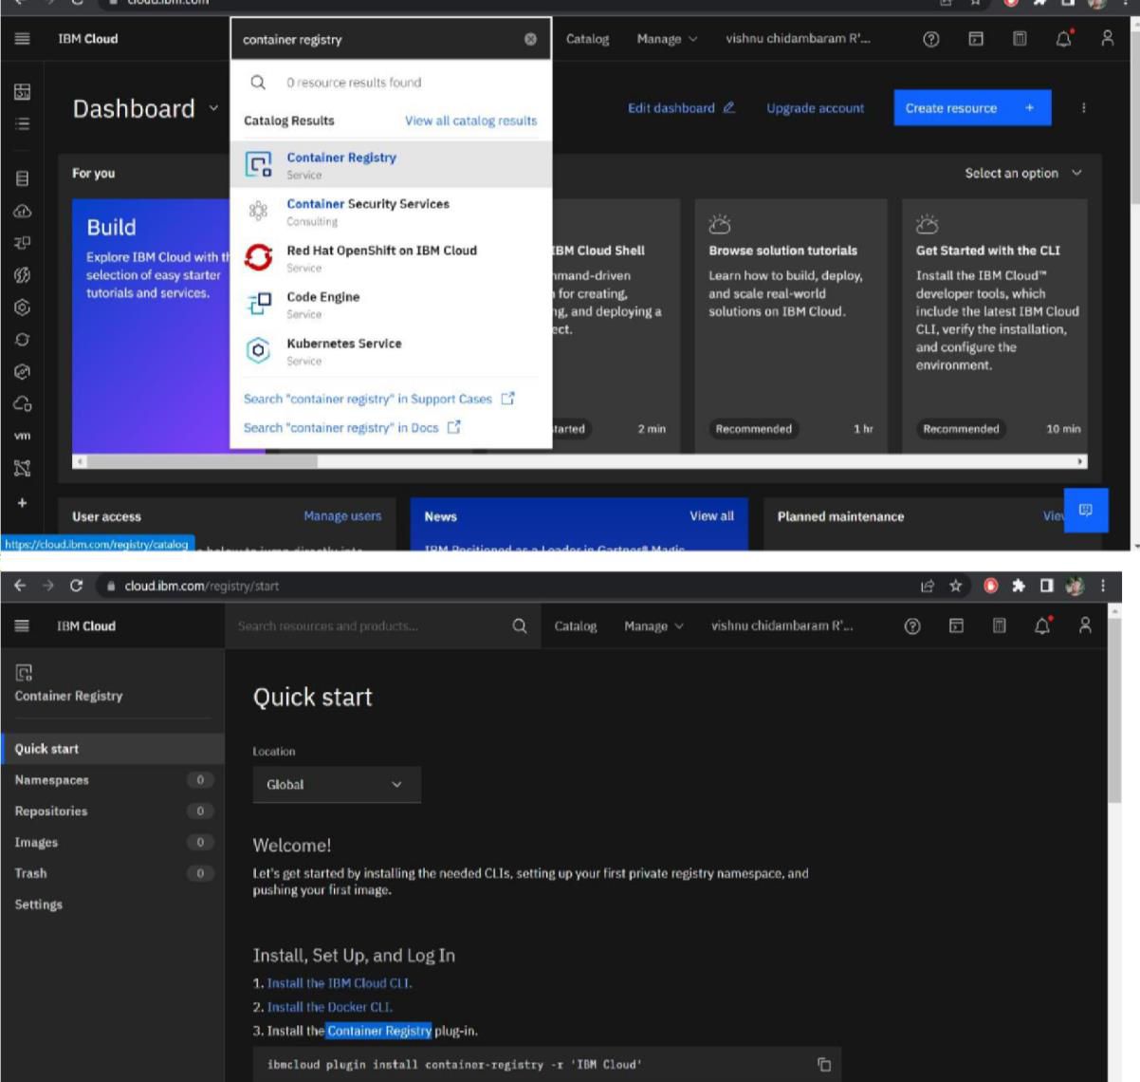

**Container registery** and click to get started.

# Step 2:

Follow and do the step given in this page one by one

[***https://cloud.ibm.com/registry/***](https://cloud.ibm.com/registry/%20start)[***start***](https://cloud.ibm.com/registry/%20start)

# Step 3:

Run the command in power shell,

***(New-Object Net.WebClient).DownloadString('https://clis.cloud.ibm.com***

***/install/powershell')***

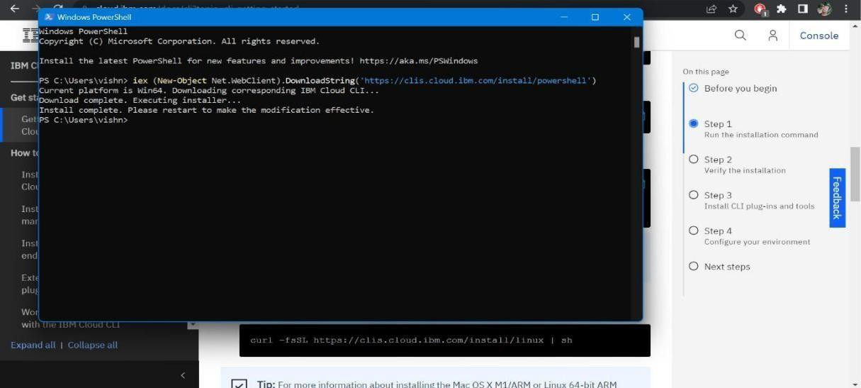

# Step 4:

Enter the command in cmd:

# Step 5:

Run all the command one by one in cmd

[***https://cloud.ibm.com/docs/containers?topic=containers-cs_cli_install***](https://cloud.ibm.com/docs/containers?topic=containers-cs_cli_install)

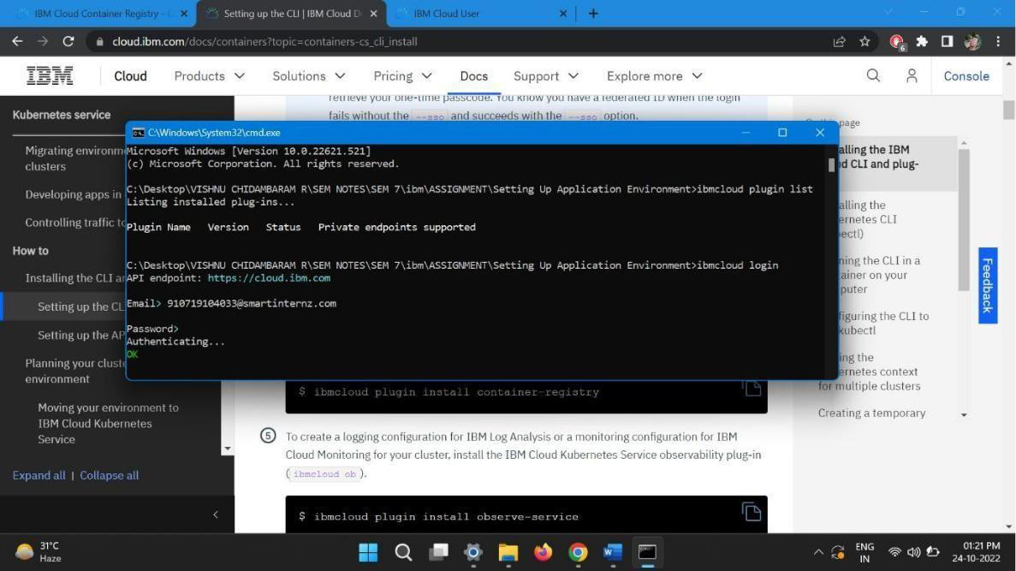

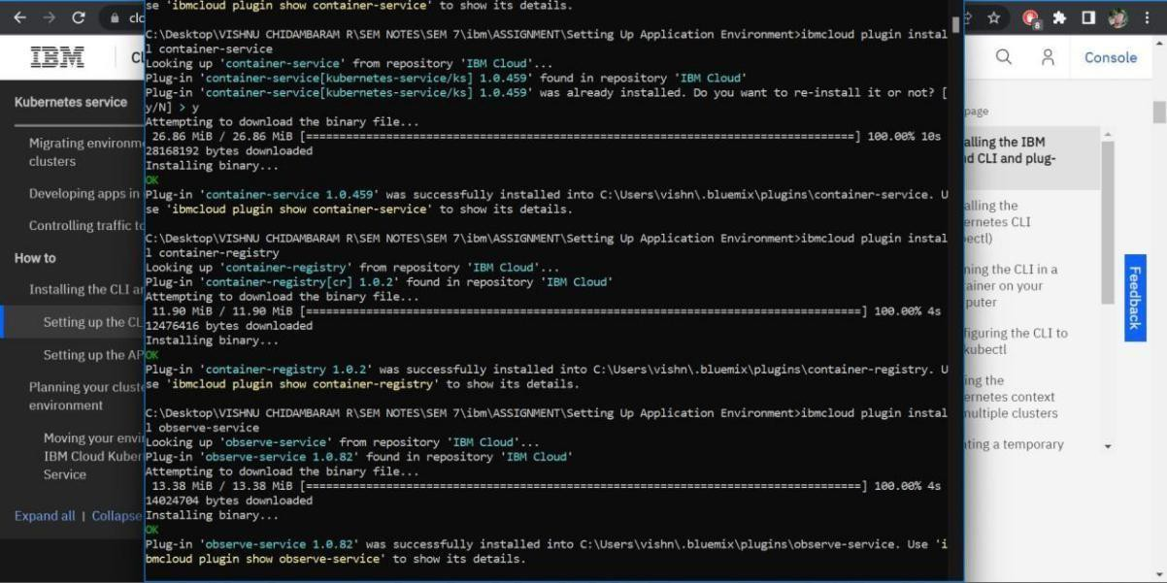

# Step 6:

Finally, you will get the IBM CLOUD CLI in your desktop